**Java Full Stack Development**

**Skilling-1**

**ID NO: 190030677 Name: K. Sravani**

1. Develop a JDBC application where KL University students will be able to choose their specialization. But there will be limited slots for each specialization which must be stored and queried from database. After successfully selecting a specialization, Specialization along with student details must be stored in the database.

a) Limit the slots for specialization

b) User should be able to choose a specialization

c) Once chose, Slots must be updated then student data must be saved in the database.

d) View the Students data.

**Code Screenshots:**

**Output Screenshots:**

**Before entering details:**

**Database Screenshots:**

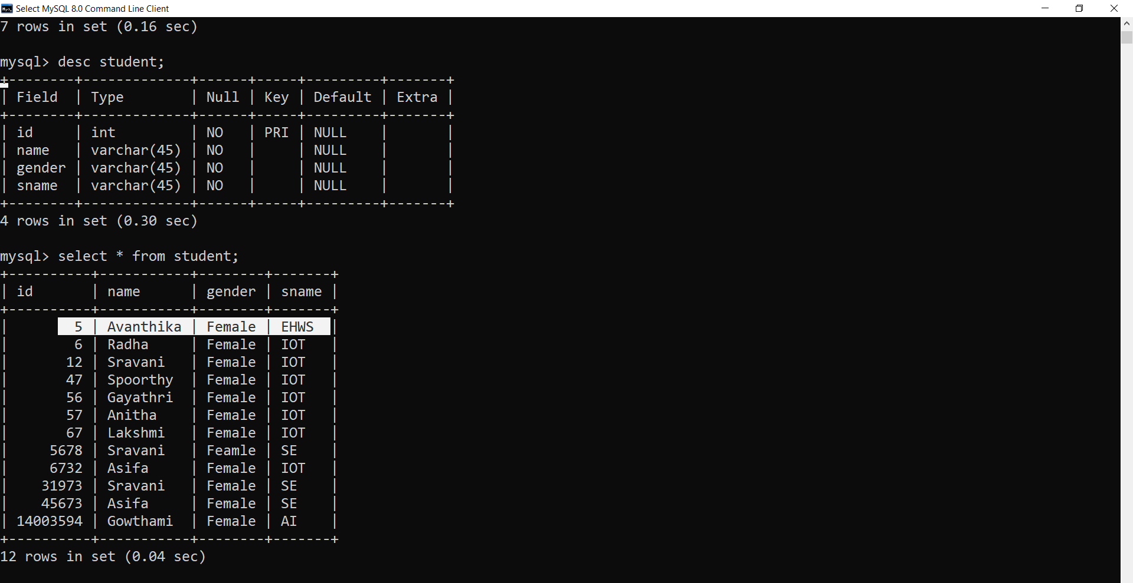

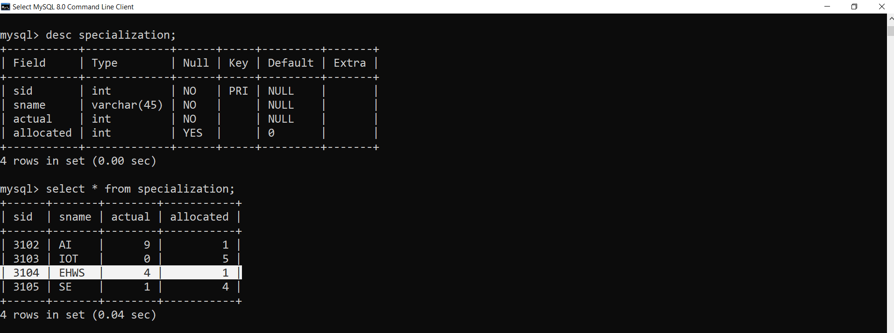

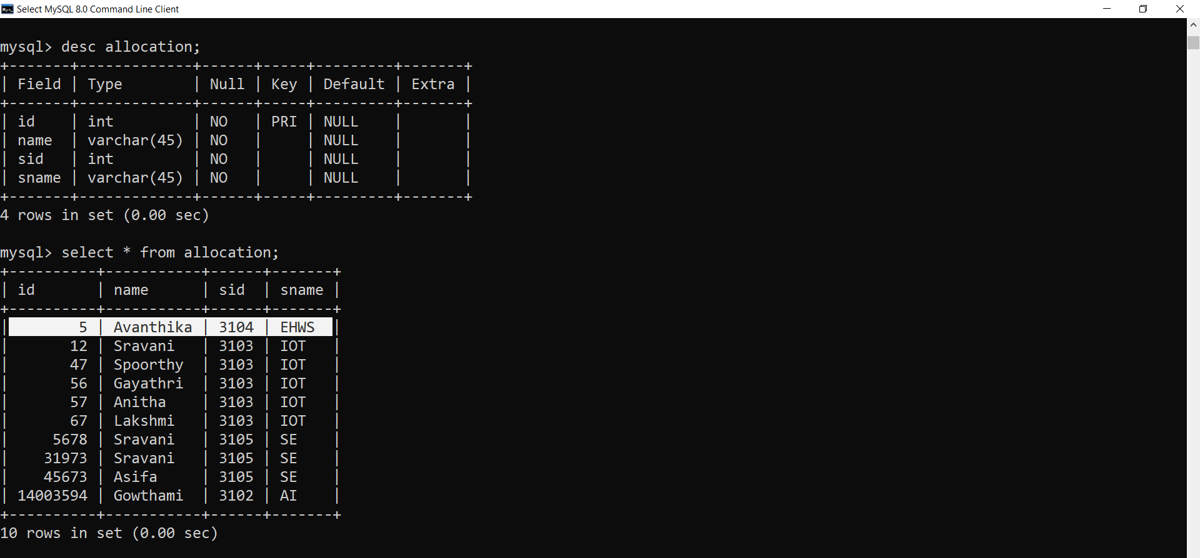

2. We are entering into the 3rd year of our B. Tech; we all are aware that CRT (Campus Recruitment Training) starts from the sixth semester. Students are instructed to clear all the backlogs and try to increase their CGPA (Cumulative Grade Point Average) to get selected in CRT Programming. For that our Management wants to maintain the data in a database. Our Management wants you to create a table containing the details of students (Student ID Number, Student name, Gender, Year of Study, Department, K L Mail, CGPA, No of Backlogs present). Store at least 5 records in the database.

As per the instructions, few students cleared their backlogs and increased their CGPA, so you are instructed to update their backlogs and CGPA

Based on CGPA, if the CGPA is greater than 7.5 they are eligible to CRT Program and remaining students are not eligible. Delete the list of students who are not eligible and print the eligible students in console.

Apply Junit test cases for the above database.

Test Cases will be on:

Connection Establishment.

Check the backlogs are updated or not for those who cleared their backlogs.

**Code Screenshots:**

**Junit Unit Testing:**

**Output Screenshots:**

**Database Screenshots:**

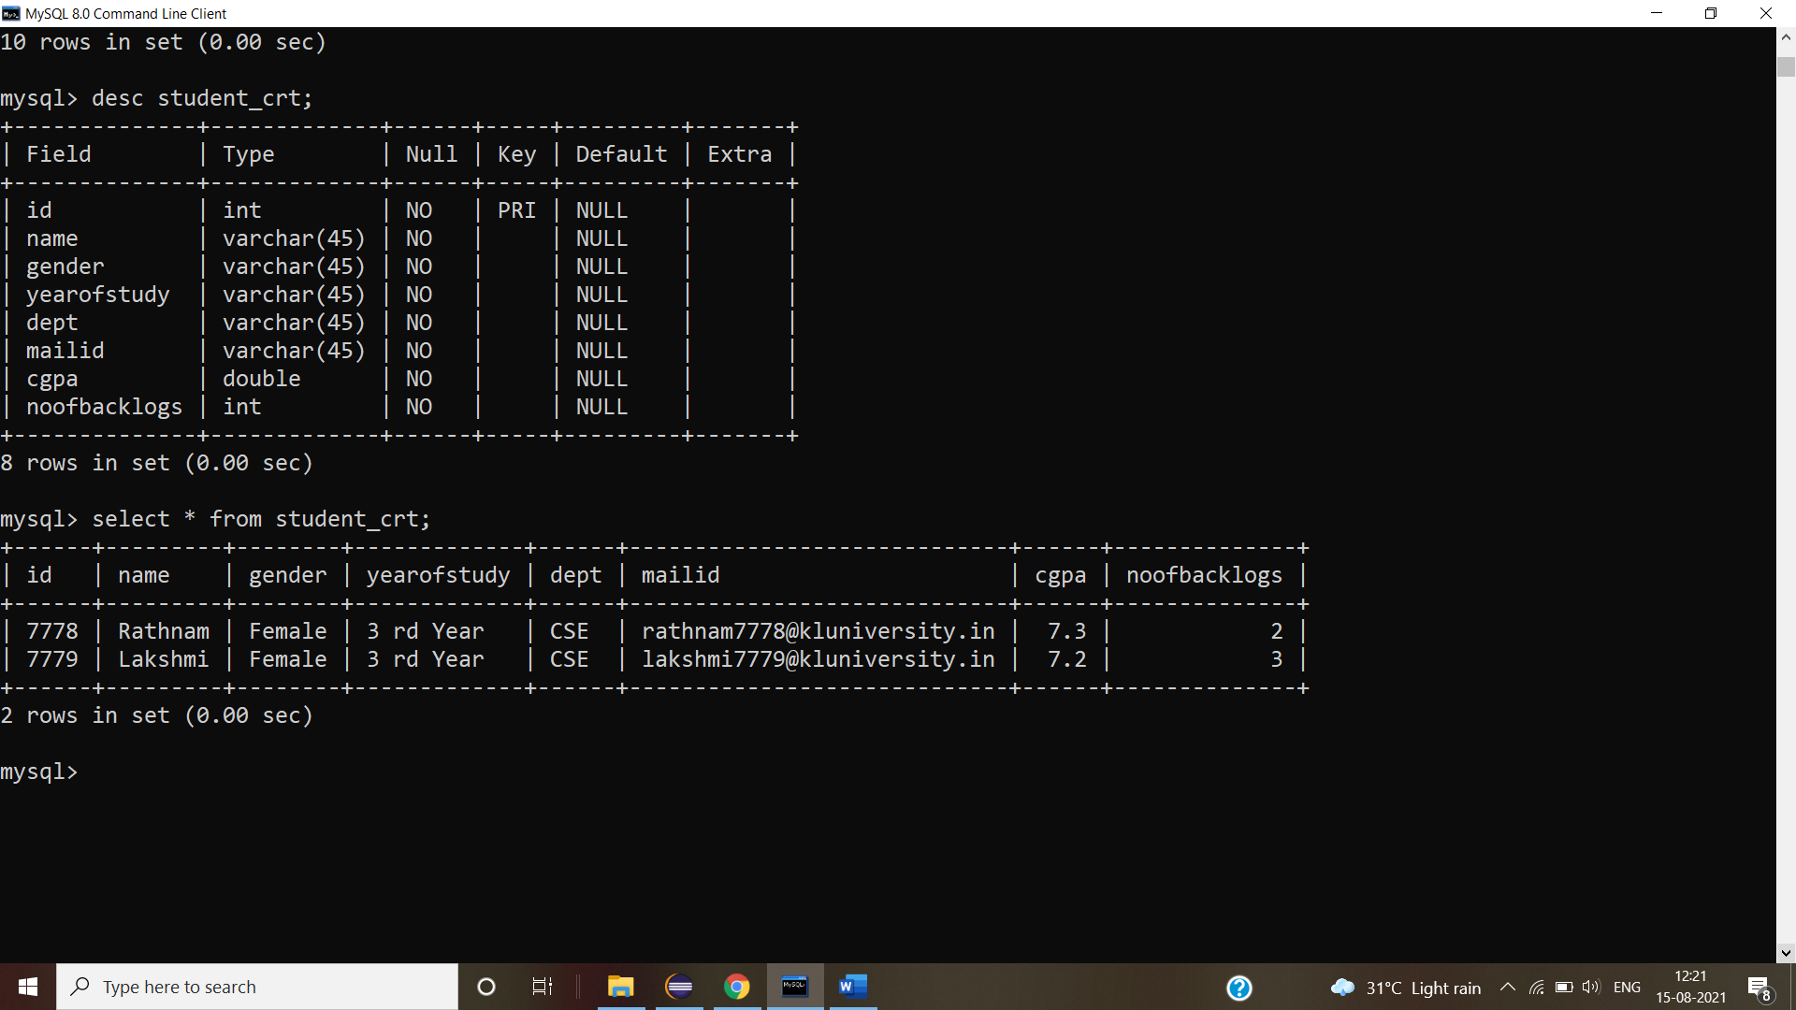

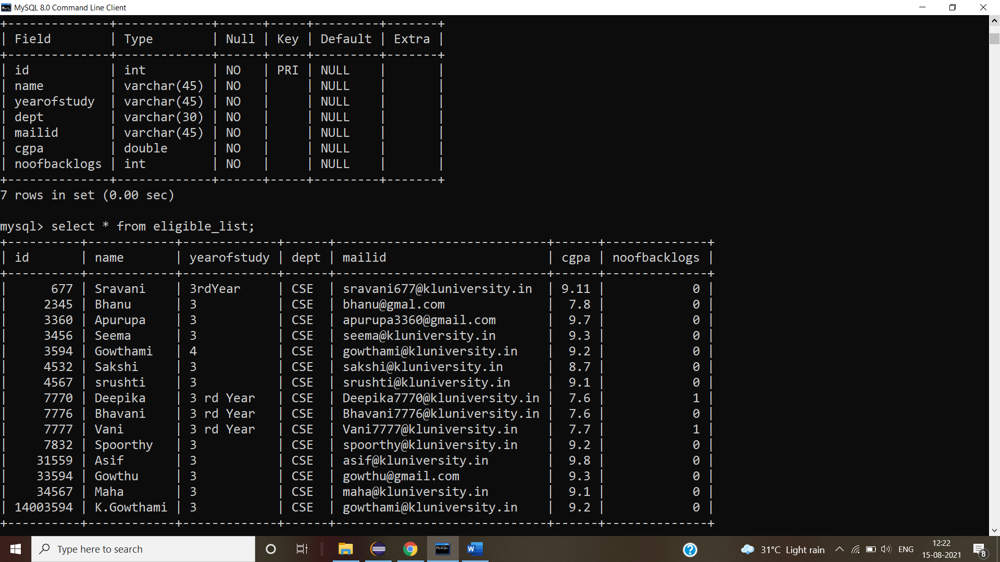

**Junit Testing Output Screenshots:**



